REPORT INDEX
Sr. No. | Topic | Sub-Topic | Page
1 | Introduction
 | 1.1 | Objective of the Internship
 | 1.2 | Overview of the Company
 | 1.3 | Duration and Nature of Work
2 | Company Profile
 | 2.1 | Background and History
 | 2.2 | Vision, Mission, and Values
 | 2.3 | Services and Products
 | 2.4 | Technology Stack
3 | Internship Activities
 | 3.1 | Week 1 –
 | 3.2 | Week 2 –
 | 3.3 | Week 3 –
 | 3.4 | Week 4 –
4 | Tools and Technologies Used
 | 4.1 | Programming Languages
 | 4.2 | Development Tools and IDEs
 | 4.3 | Project Management Tools
 | 4.4 | Version Control Systems
5 | Learning Outcomes
 | 5.1 | Technical Skills Gained
 | 5.2 | Industry Exposure
 | 5.3 | Competencies Developed (Technical/Communication/Teamwork)
6 | Conclusion
 | 6.1 | Summary of Experience
 | 6.2 | Future Scope and Problem Statements
7 | Annexure / Appendix
 | 7.1 | Internship Completion Certificate
 | 7.2 | Code Snippets and Screenshots
 | 7.3 | Feedback from Industry Mentor Industry Feedback Summary
 | 7.4 | Photos with geotags and Reviews
 | 7.5 | Logbook

Chapter -1 Introduction

1.1 Objective of the Internship:
- Enhanced Employability and Research Capability Development - I sought to enhance my employability by developing practical AI/ML skills that would make me competitive in the job market while building research capabilities for both commercial applications and academic opportunities in technology companies and research institutions.
- Immersive Experience with Cutting-Edge Technologies - I intended to gain hands-on experience with state-of-the-art AI/ML technologies transforming industries like healthcare, finance, and automotive by working with real datasets, implementing algorithms, and understanding how these technologies solve actual business problems.
- Industry-Standard Tools and Framework Proficiency - Planned to learn TensorFlow and essential industry tools that form the foundation of modern AI applications, ensuring I could work effectively with the same technological stack used by leading tech companies and contribute to enterprise-scale projects.
- Computer Vision and Deep Learning Expertise - I aimed to develop expertise in computer vision techniques including image classification and object detection, while mastering neural network architectures like CNNs and transformers to tackle complex visual recognition problems across various applications.
- Practical Implementation and Professional Application - I sought to acquire skills in translating theoretical AI/ML concepts into working solutions for real-world environments, learning the complete machine learning pipeline from data preprocessing to production deployment while understanding scalability and performance considerations.

1.2 Overview of the Company:
Google LLC stands as one of the world's most influential technology corporations, with its headquarters in Mountain View, California. Since its founding in 1998, Google has evolved from a search engine start up to a global technology giant that fundamentally shapes how billions of people access, process, and interact with information daily. The company's mission to "organize the world's information and make it universally accessible and useful" has driven continuous innovation across multiple technological domains.
As a pioneer and leader in artificial intelligence and machine learning, Google has consistently pushed the boundaries of what's possible with AI technology. The company's AI-powered ecosystem encompasses a vast array of products and services that have become integral to modern digital life. Google Search, powered by sophisticated machine learning algorithms, processes over 8.5 billion searches daily, providing users with increasingly accurate and contextually relevant results. Google Assistant, the company's AI-powered virtual assistant, demonstrates advanced natural language processing capabilities, enabling seamless human-computer interaction across multiple devices and platforms.
Google Photos showcases the company's expertise in computer vision and image recognition, automatically organizing and categorizing billions of photos while providing intelligent search capabilities. Google Translate breaks down language barriers through neural machine translation, supporting over 100 languages and facilitating global communication. These applications represent just a fraction of Google's AI-powered innovation portfolio.
The company's commitment to advancing AI research is embodied in Google AI, formerly known as Google Research. This division represents one of the world's leading AI research organizations, consistently publishing ground breaking research in machine learning, deep learning, natural language processing, and computer vision. Google AI researchers have contributed fundamental advances including the Transformer architecture, which revolutionized natural language processing, and numerous breakthroughs in reinforcement learning and computer vision.
Google's development of TensorFlow, an open-source machine learning framework, demonstrates the company's commitment to democratizing AI technology. TensorFlow has become the most widely adopted machine learning platform globally, enabling developers, researchers, and organizations worldwide to build and deploy AI applications efficiently.
Through initiatives like virtual internship programs, Google continues to invest in AI education and talent development, ensuring that the next generation of technologists is well-equipped to drive future innovations in artificial intelligence and machine learning.

1.3 Duration and Nature of Work:
The Google AI-ML Virtual Internship is meticulously crafted 4 – week internship program, designed to provide participants with immersive, hands-on experience in AI, machine learning, and data science—mirroring the dynamic, real-world environment. This carefully designed duration strikes an optimal balance between providing comprehensive coverage of essential AI/ML concepts and maintaining the focused intensity necessary for meaningful skill development. The timeframe allows for progressive learning, where foundational concepts are established in the initial weeks and gradually built upon with increasingly complex applications and projects.
The virtual nature of this internship represents a paradigm shift in professional development, leveraging advanced online platforms and digital collaboration tools to create an immersive learning environment that transcends traditional geographical boundaries. Participants access state-of-the-art learning management systems, interactive coding environments, and virtual laboratories that simulate real-world AI/ML development scenarios. This remote delivery model ensures accessibility for students from diverse backgrounds and locations, democratizing access to high-quality AI education and industry exposure.
The program architecture seamlessly integrates theoretical learning with practical project implementation, creating a comprehensive educational experience that mirrors the dual nature of professional AI/ML work. The theoretical component encompasses fundamental concepts in machine learning algorithms, including supervised and unsupervised learning techniques, reinforcement learning principles, and statistical modelling approaches. Participants delve deep into the mathematical foundations underlying these algorithms, understanding not just how to implement them but why they work and when to apply specific techniques.
Computer vision techniques form a substantial portion of the curriculum, with participants exploring image processing, object detection, facial recognition, and scene understanding. The program covers both classical computer vision methods and modern deep learning approaches, providing students with a comprehensive toolkit for visual AI applications. Practical exercises include working with convolutional neural networks, image segmentation, and real-time video analysis.
Neural network development constitutes another cornerstone of the program, where participants learn to design, implement, and optimize various neural architectures. From basic perceptron to complex deep neural networks, students gain hands-on experience with backpropagation, gradient descent optimization, and regularization techniques. Advanced topics include recurrent neural networks for sequential data, transformer architectures for natural language processing, and generative adversarial networks for creative AI applications.
The structured learning approach incorporates weekly assignments that serve as both assessment tools and practical reinforcement of concepts learned. These assignments are carefully crafted to progressively increase in complexity, ensuring that participants build confidence while continuously challenging their understanding. Each assignment typically involves implementing specific algorithms, analysing datasets, and presenting findings in professional formats.
Collaborative projects represent a unique aspect of the program, simulating real-world team dynamics in AI/ML development. Participants work in diverse teams to tackle complex, multi-faceted problems that require integration of multiple AI/ML techniques. These projects foster communication skills, project management capabilities, and the ability to work effectively in interdisciplinary teams—all essential skills for professional success.
The mentorship component provides invaluable industry insights through regular sessions with experienced AI/ML practitioners and researchers from Google. These mentors offer personalized guidance, career advice, and real-world perspectives on AI/ML applications across various industries. Mentorship sessions include code reviews, project feedback, and discussions about emerging trends and future directions in AI/ML technology, ensuring participants remain at the forefront of industry developments.

Chapter – 2 Company Profile

2.1 Background and History
Google's remarkable journey began in 1998 when two visionary PhD students at Stanford University, Larry Page and Sergey Brin, embarked on a mission that would fundamentally transform how humanity accesses and processes information. Initially conceived as a research project called "BackRub," their innovative approach to web search utilized a revolutionary algorithm that analyzed the relationships between websites, ultimately evolving into the PageRank algorithm that became the foundation of Google's search engine.
The company's early years were marked by rapid growth and technological innovation. Operating initially from a garage in Menlo Park, California, Google quickly distinguished itself from existing search engines through its clean interface, lightning-fast results, and superior relevance rankings. The founders' academic background in computer science and their deep understanding of information retrieval systems enabled them to create a search engine that could effectively navigate the exponentially growing World Wide Web.
Google's initial public offering in 2004 marked a pivotal moment in the company's evolution, providing the capital necessary for aggressive expansion and research investment. This period saw the launch of groundbreaking products including Gmail, Google Maps, and Google News, each incorporating increasingly sophisticated algorithms and data processing capabilities.
The company's commitment to artificial intelligence and machine learning research began remarkably early in its corporate history, recognizing that AI technologies would be essential for managing and understanding the vast amounts of data generated by internet users worldwide. This prescient investment in AI research has proven to be one of Google's most strategic decisions, as machine learning algorithms now power virtually every aspect of the company's operations, from search result rankings to advertisement targeting, from email spam detection to voice recognition in mobile devices.
Throughout the 2000s and 2010s, Google systematically acquired talented researchers and promising AI startups, building one of the world's most formidable artificial intelligence research teams. Notable acquisitions included DeepMind Technologies in 2014, which brought world-class expertise in deep learning and reinforcement learning, and numerous smaller AI companies that contributed specialized knowledge in computer vision, natural language processing, and robotics.
Today, Google stands as one of the "Big Four" technology companies alongside Amazon, Apple, and Microsoft, with a market capitalization exceeding $1 trillion and a global workforce of over 150,000 employees. The company's evolution from a simple search engine to a comprehensive technology ecosystem demonstrates the transformative power of sustained investment in research and development, particularly in artificial intelligence and machine learning technologies.

2.2 Vision, Mission, and Values
Vision: To organize the world's information and make it universally accessible and useful.
This foundational vision statement, established during Google's early years, continues to guide the company's strategic direction and product development decisions. The vision encompasses not just the technical challenge of organizing information, but also the broader societal goal of democratizing access to knowledge regardless of geographical, economic, or social barriers. In the context of artificial intelligence, this vision has evolved to include the organization and accessibility of diverse data types including images, videos, audio, and sensor data from Internet of Things devices.
Mission: To make AI beneficial for everyone by developing technologies that solve important problems and improve lives globally.
Google's mission has evolved to explicitly embrace artificial intelligence as a primary vehicle for positive global impact. This mission statement reflects the company's recognition that AI technologies possess unprecedented potential to address complex challenges in healthcare, education, environmental sustainability, and economic development. The emphasis on "beneficial for everyone" underscores Google's commitment to ensuring that AI advances serve diverse populations and contribute to reducing rather than exacerbating global inequalities.
Values: Focus on the user, innovation, collaboration, and responsible AI development with ethical considerations.
The company's core values framework provides ethical and operational guidance for all AI/ML research and development activities. "Focus on the user" emphasizes human-centred design principles, ensuring that AI systems enhance rather than replace human capabilities. "Innovation" represents Google's commitment to pushing the boundaries of what's possible with AI technology while maintaining practical applicability. "Collaboration" reflects the company's belief that the most significant AI breakthroughs emerge from interdisciplinary teamwork and open scientific collaboration. "Responsible AI development with ethical considerations" acknowledges the profound societal implications of AI technologies and commits the company to developing AI systems that are fair, transparent, and aligned with human values.

2.3 Services and Products
Google's comprehensive AI-ML portfolio represents one of the most extensive and sophisticated artificial intelligence ecosystems in the technology industry, spanning from foundational research tools to consumer-facing applications that serve billions of users daily.
TensorFlow stands as Google's flagship contribution to the global AI community, serving as the world's most widely adopted open-source machine learning framework. Since its public release in 2015, TensorFlow has democratized access to advanced machine learning capabilities, enabling developers, researchers, and organizations worldwide to build and deploy sophisticated AI applications. The framework supports everything from simple linear regression models to complex neural networks with billions of parameters, offering unprecedented flexibility and scalability for AI development.
Google Cloud AI Platform provides enterprise-grade machine learning services and tools that enable businesses to integrate AI capabilities into their operations without requiring extensive in-house AI expertise. The platform offers pre-trained models for common use cases, custom model training capabilities, and scalable deployment infrastructure that can handle production workloads ranging from small applications to global-scale systems serving millions of users.
Vision API delivers state-of-the-art computer vision capabilities through easily accessible web APIs, enabling developers to incorporate image recognition, optical character recognition, and object detection into their applications. The API can identify thousands of objects, landmarks, and faces within images, making it valuable for applications ranging from content moderation to accessibility tools for visually impaired users.
Natural Language API provides sophisticated text analysis and understanding capabilities, including sentiment analysis, entity recognition, and syntax analysis. This API enables applications to understand and process human language with remarkable accuracy, supporting multiple languages and dialects while maintaining cultural and contextual sensitivity.
AutoML represents Google's innovative approach to democratizing machine learning by automating the complex process of model development. This suite of tools enables users with limited machine learning expertise to create custom, high-performance models for their specific use cases, significantly reducing the time and expertise required for AI implementation.
AI-powered consumer products including Google Photos, Google Assistant, and Google Translate demonstrate the practical application of Google's AI research in products used by billions of people daily. Google Photos utilizes computer vision to automatically organize and search through personal photo collections, while Google Assistant leverages natural language processing and speech recognition to provide intelligent virtual assistant capabilities across multiple devices and platforms.

2.4 Technology Stack
Google's technology stack represents a comprehensive ecosystem of programming languages, frameworks, tools, and services specifically optimized for artificial intelligence and machine learning development at scale.
Programming Languages:
- Python - Primary language for AI/ML development and backend processing
- JavaScript - Used for frontend web development and TensorFlow.js implementation
- HTML/CSS - For web interface structure and styling

AI/ML Frameworks & Libraries:
- TensorFlow (v2+) - Main deep learning framework for model training and inference
- TensorFlow.js - For browser-based machine learning and real-time inference
- OpenCV - Computer vision library for image processing
- NumPy - Numerical computing library for array operations

Frontend Technologies:
- React.js - JavaScript library for building interactive user interfaces
- Streamlit - Python framework for creating web applications and UI

Pre-trained Models:
- COCO-SSD - Pre-trained object detection model for identifying 80 common object classes
- Custom CNN model (recycle_classifier.h5) - Custom trained model for recyclability classification

Development Tools & Platforms:
- Google Colab - Cloud-based Jupyter notebook environment for development
- Google Teachable Machine - Tool for creating custom machine learning models
- Google Developers Pathways - Learning platform and course structure

Web Technologies:
- Browser-based execution - Client-side model inference without backend
- Webcam API - For real-time video capture and processing
- File upload functionality - For image classification tasks

Project-Specific Features:
- Real-time object detection - Live webcam feed processing
- Image classification - Binary classification for recyclable/non-recyclable items
- Bounding box visualization - Object detection with visual overlays
- Multi-category classification - 7 waste categories mapped to recyclable/non-recyclable

Dependencies Management:
- requirements.txt - Python package dependencies management
- pip - Package installer for Python libraries

Project Management Tools:
- Google Drive: File sharing and collaboration
- GitHub: Version control and project hosting
- Google Meet: Virtual meetings and mentorship sessions

Version Control Systems:
- Git: Distributed version control system
- GitHub: Remote repository hosting and collaboration
- GitLab: Alternative version control platform for certain projects

Chapter – 3 Internship Activities

Week 1: Foundation & Setup (22 Hours)
Technical Setup & Environment Configuration:
- Installed Python 3.8+, TensorFlow 2.x, NumPy, and OpenCV libraries
- Set up virtual development environment and Google Colab workspace
- Created comprehensive GitHub repository with proper project structure
- Completed Google Developer Unit 1: TensorFlow Basics
Computer Vision Fundamentals:
- Implemented image loading, preprocessing, and manipulation using OpenCV
- Studied CNN architecture fundamentals and neural network basics
- Explored pre-trained models and transfer learning concepts
- Developed basic image processing scripts and CNN implementation notebooks
Project Planning & Documentation:
- Designed project roadmap for three main deliverables
- Created detailed README documentation and version control setup
- Established development workflow and coding standards

Week 2: Object Detection Development (22 Hours)
COCO-SSD Model Implementation:
- Completed Google Developer Unit 2: Object Detection Basics
- Studied COCO-SSD architecture and 80 object classes capabilities
- Set up TensorFlow.js development environment for browser-based ML
- Built static image object detection demo with model integration
Real-time Web Application:
- Developed React.js frontend with webcam access components. Implemented real-time object detection on video streams
- Created bounding box visualization using HTML5 Canvas
- Designed responsive user interface with real-time feedback
Performance Optimization:
- Optimized application performance to reduce detection latency
- Added comprehensive error handling and user feedback systems
- Conducted cross-browser compatibility testing
- Created detailed project documentation and demonstration videos

Week 3: Custom Model Development (29 Hours)
Dataset Creation & Preprocessing:
- Completed Google Developer Unit 6: Image Classification
- Collected and curated recyclable/non-recyclable image dataset
- Implemented data augmentation techniques for model robustness
- Developed comprehensive data preprocessing pipeline
Custom CNN Architecture:
- Designed binary classification CNN for recyclability detection
- Implemented custom model architecture using TensorFlow/Keras
- Conducted hyperparameter tuning and model optimization
- Created model evaluation reports with confusion matrices and performance graphs
Model Deployment:
- Set up Streamlit development environment for web deployment
- Built interactive web interface for image upload and classification
- Integrated trained model for real-time inference capabilities
- Implemented result visualization and user feedback systems

Week 4: Integration & Presentation (21 Hours)
System Integration:
- Combined object detection and image classification modules
- Developed unified Smart Desk Classifier application. Implemented desk item detection with recyclability analysis
- Created comprehensive multi-modal AI application
Testing & Documentation:
- Conducted extensive testing across all application features
- Performed performance optimization and comprehensive bug fixes
- Created detailed technical documentation and user guides
- Prepared professional demonstration videos and presentations
Portfolio & Certification:
- Built complete Google Developer Profile with earned badges
- Prepared comprehensive final presentation covering all projects
- Submitted complete portfolio for internship evaluation
- Completed internship reflection and learning outcome summary

Chapter – 4 Tools and Technologies Used

4.1 Programming Languages
- Python - Primary language for AI/ML development and backend processing. Industry standard with extensive libraries (TensorFlow, PyTorch, scikit-learn).
- JavaScript - Used for frontend web development and TensorFlow.js implementation. Enables browser-based ML applications and interactive interfaces.
- HTML/CSS - For web interface structure and styling. Essential for creating user-friendly web applications and dashboards.

4.2 Development Tools & Platforms
- Google Colab - Cloud-based Jupyter notebook environment for development. Provides free GPU access and collaborative coding capabilities.
- Google Teachable Machine - Tool for creating custom machine learning models. No-code solution for rapid prototyping and model creation.
- Google Developers Pathways - Learning platform and course structure. Structured educational content for skill development.
- VS Code - Lightweight, extensible code editor. Excellent support for Python, JavaScript, and AI/ML extensions.

4.3 Project Management Tools
- Google Drive - File sharing and collaboration platform. Centralized storage for documents, datasets, and project resources.
- GitHub - Version control and project hosting platform. Code repository management with collaboration features.
- Google Meet - Virtual meetings and mentorship sessions. Video conferencing for team communication and code reviews.

4.4 Version Control Systems
- Git - Distributed version control system. Tracks code changes and enables collaborative development workflows.
- GitHub - Remote repository hosting and collaboration platform. Cloud-based Git hosting with project management features.
- GitLab - Alternative version control platform for certain projects. Offers integrated DevOps capabilities and CI/CD pipelines.

Chapter – 5 Learning Outcomes

5.1 Technical Skills Gained
TensorFlow and Keras Framework Proficiency
- Developed comprehensive understanding of TensorFlow's ecosystem
- Gained expertise in building sequential and functional models using Keras

Computer Vision and Image Processing Techniques
- Developed proficiency in convolutional neural networks (CNNs) for image classification tasks
- Learned image segmentation methods including semantic and instance segmentation
- Gained experience with transfer learning using pre-trained models

Neural Network Fundamentals
- Knowledge of different neural network architectures including feedforward, recurrent, and convolutional networks
- Understanding of loss functions and their mathematical foundations
- Learning of weight initialization strategies and their impact on training
- Knowledge of overfitting, underfitting, and bias-variance trade-off concepts

5.2 Industry Exposure
The internship provided significant exposure to industry-standard AI/ML development practices , which reflect current industry approaches to machine learning implementation. Working with TensorFlow, the industry's leading open-source machine learning framework, gave me hands-on experience with the same tools and methodologies used by major tech companies and startups worldwide. The curriculum's emphasis on practical deployment scenarios, including mobile integration with TensorFlow Lite and cloud-based AI services, provided insight into how modern businesses implement scalable AI solutions. Learning to build custom object detection models and image classification systems using different libraries exposed me to the rapid prototyping and development cycles common in the AI industry. The focus on production-ready solutions, from handling larger datasets to avoid overfitting to optimizing models for mobile deployment, gave me understanding of the real-world challenges and constraints that AI engineers face when transitioning from research to commercial applications.

5.3 Competencies Framework

Technical Skills

During the internship, I learned how to build and improve machine learning models using different programming tools and techniques. I gained experience working with various types of data and learned how to make models work faster and more accurately. In computer vision, I built applications that can recognize objects in images and videos, process images in real-time, and improve image quality through preprocessing. I also learned how to use existing trained models to quickly create new applications and build tools to prepare training data from image collections.

Communication Skills

The internship helped me develop strong technical writing abilities, including creating clear documentation for software systems, writing helpful guides for users, and explaining complex code in simple terms. I learned how to make visual diagrams and flowcharts to explain technical concepts and how to keep documentation updated as projects change. I also gained experience writing professional reports and creating consistent documentation standards for team projects.

Teamwork Skills

I learned how to work effectively with remote teams using online meeting tools and digital collaboration platforms to coordinate projects and share work. The internship taught me essential skills in managing code with version control systems like Git, including how to share code safely with teammates, resolve conflicts when multiple people work on the same project, and set up systems for testing and deploying code. I developed good practices for organizing code so that teams can work together efficiently on large projects.

Chapter – 6 Conclusion

6.1 Summary of Experience
The Google Virtual Internship provided an exceptional learning journey that effectively bridged theoretical knowledge with practical AI/ML application through a meticulously structured curriculum progressing from fundamental concepts to advanced methodologies. The program offered invaluable mentorship from industry experts who shared technical expertise, industry trends, and real-world implementation challenges while providing access to cutting-edge tools and state-of-the-art frameworks that created an authentic professional development environment. Through comprehensive machine learning workflows spanning data preprocessing to production deployment, extensive work with TensorFlow and computer vision projects, and hands-on experience with industry-standard practices, the internship developed both technical competencies and practical insights into AI applications across various domains. The virtual format, while initially challenging, ultimately fostered strong self-directed learning skills, digital collaboration capabilities, independence, and resourcefulness that are essential in today's distributed work environment. Beyond technical skills, the experience enhanced critical thinking abilities, analytical problem-solving approaches, and confidence in tackling unfamiliar challenges while providing valuable exposure to the professional AI/ML community through networking opportunities and collaborative projects that offer ongoing career development pathways extending well beyond the formal internship period.

6.2 Future Scope and Problem Statements
Future Scope for Advanced Learning
Pursuing Advanced Specialization in Computer Vision and Deep Learning
Building upon the foundation established during the internship, the next phase involves deepening expertise in computer vision and advanced deep learning architectures. This includes exploring state-of-the-art techniques such as vision transformers, neural architecture search, and multimodal learning systems that combine visual and textual information. Advanced specialization will involve contributing to research publications and developing novel approaches to challenging computer vision problems.
Exploring Emerging AI Technologies
The rapidly evolving landscape of artificial intelligence presents exciting opportunities to explore emerging technologies like generative AI and large language models. Understanding the underlying mechanisms of these technologies and their potential applications across different industries represents a significant growth opportunity. This exploration includes hands-on experimentation with transformer architectures, attention mechanisms, and prompt engineering techniques.

Contributing to Open-Source AI Projects and Research Initiatives
Active participation in open-source AI projects provides opportunities to collaborate with the global AI community while contributing to the advancement of accessible AI technologies. This involvement includes contributing code, documentation, and research findings to established projects while also initiating new projects that address specific community needs or research gaps.

Developing AI Solutions for Social Impact and Sustainability
Applying AI technologies to address pressing social and environmental challenges represents a meaningful direction for future work. This involves developing solutions for healthcare accessibility, educational equity, environmental monitoring, and sustainable development goals. Such applications require not only technical expertise but also understanding of social contexts and ethical considerations.

Problem Statements for Future Work
1. Creating AI Solutions for Accessibility and Inclusive Technology
Many AI applications inadvertently exclude users with disabilities or fail to consider diverse user needs in their design and implementation.
2. Implementing Explainable AI for Better Model Interpretability
Many advanced AI models operate as "black boxes," making it difficult to understand their decision-making processes, which limits their adoption in critical applications like healthcare and finance.
3. Addressing Bias and Fairness in Machine Learning Systems
AI systems can perpetuate or amplify existing societal biases present in training data, leading to unfair outcomes for certain demographic groups.

Chapter – 7 Annexure / Appendix

7.1 INTERNSHIP COMPLETION CERTIFICATE
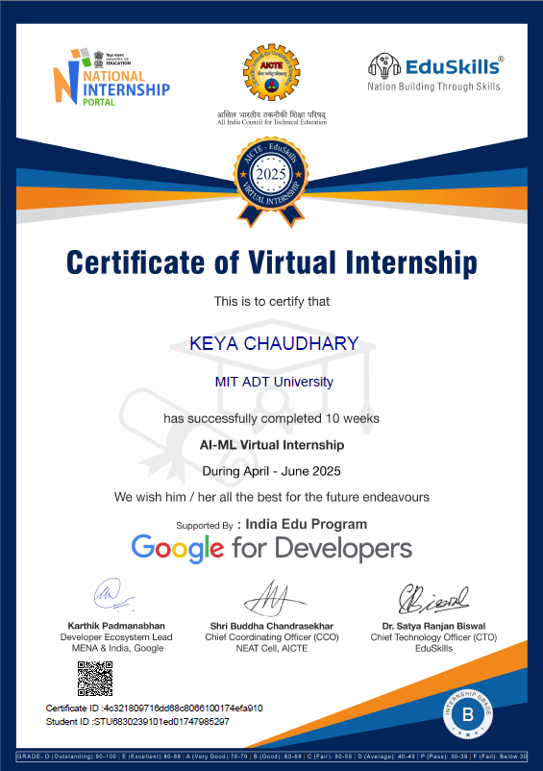

7.2 CODE SNIPPETS AND SCREENSHOTS

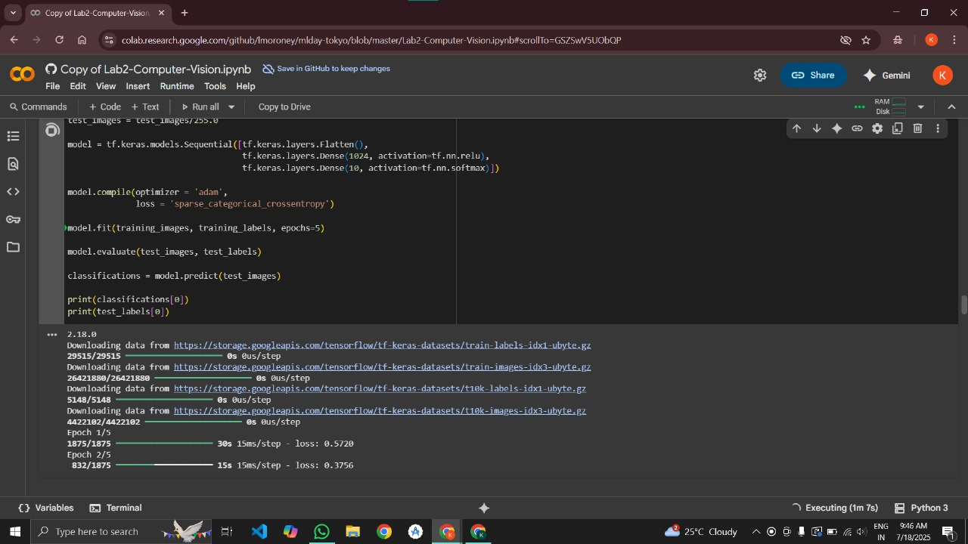
Snippet 1 : Unit -1 Colab 1

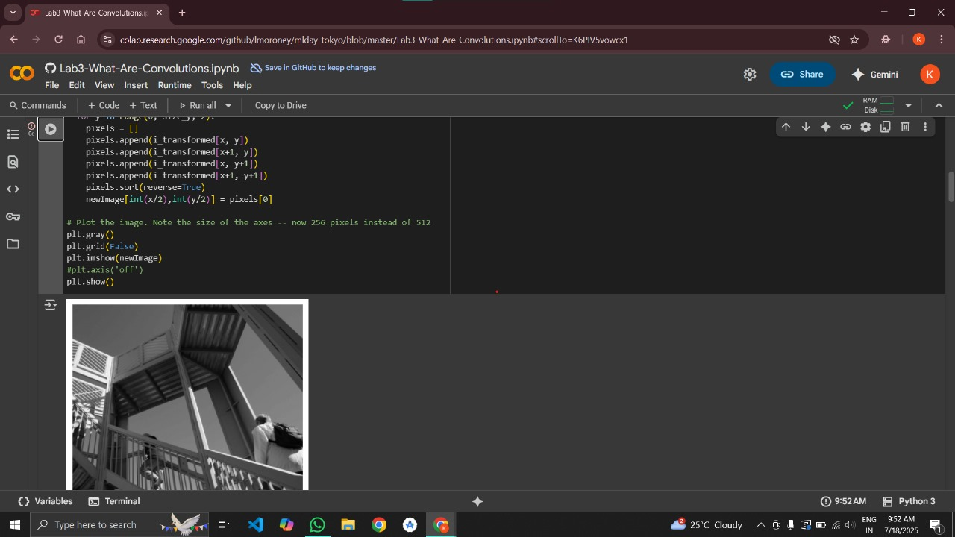
Snippet 2 : Unit – 1 Colab 2

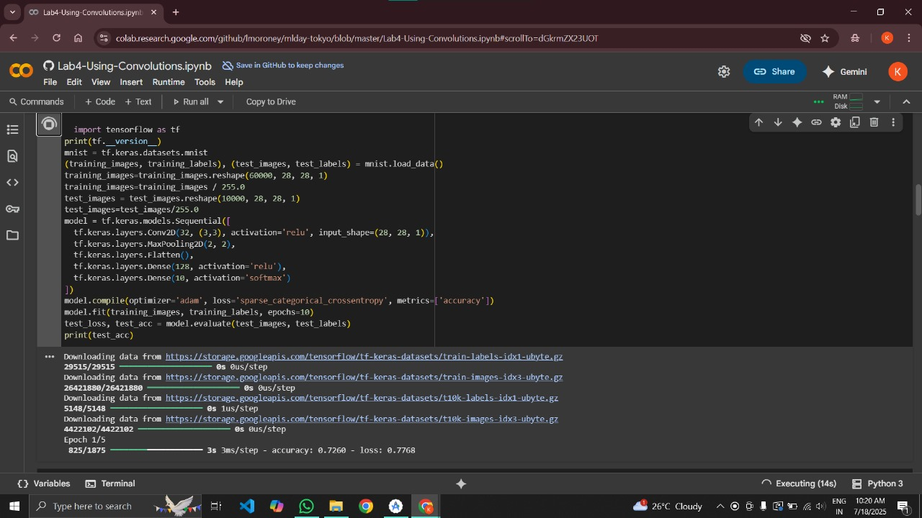
Snippet 2 : Unit – 1 Colab 3

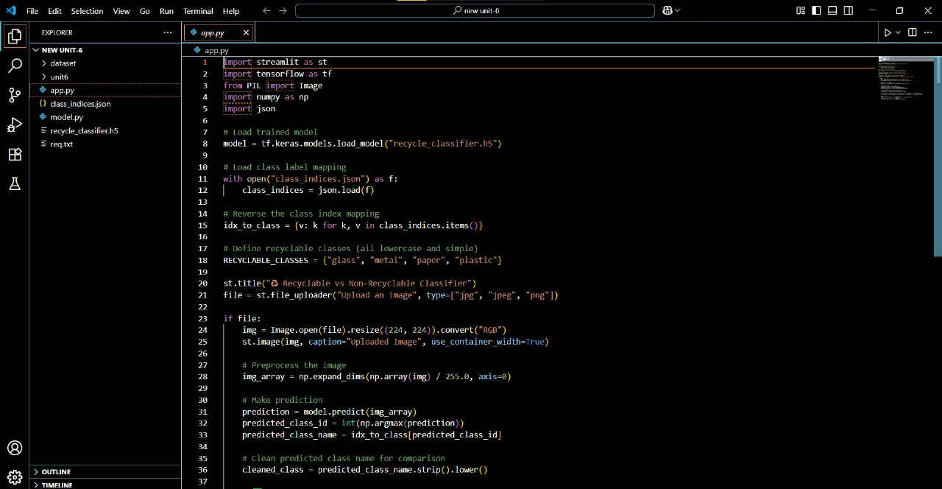
Code Snippet 1 : Recylable Vs. Non-recylable Image Classification

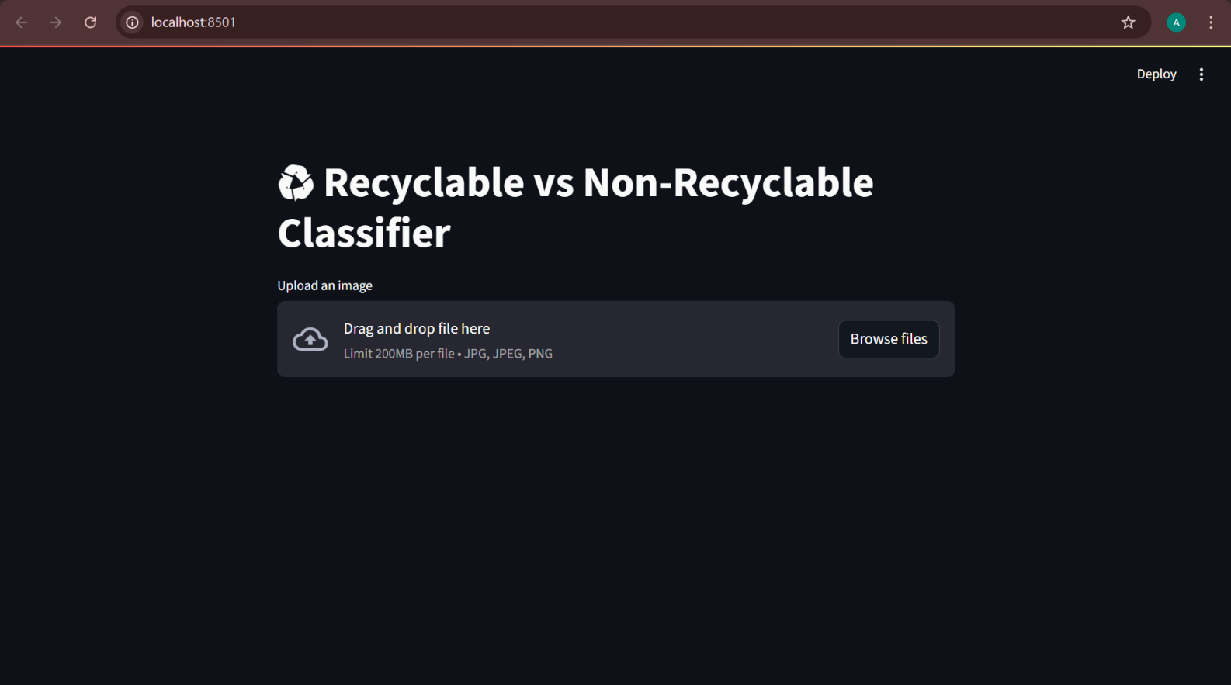
Result 1 : Recylable Vs. Non-recylable Image Classification UI

This project is a custom image classifier that detects whether an item belongs to the recyclable or non-recyclable category. Built using Python and TensorFlow, it promotes eco-friendly practices by assisting in waste categorization.

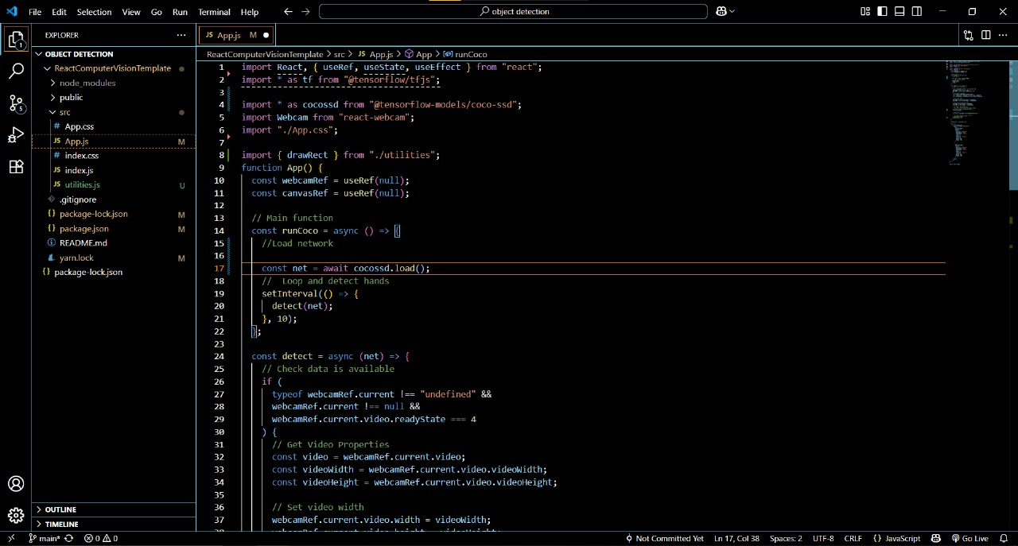
Code Snippet 2 : Object Detection App with TensorFlow.js and React.js using COCO-SSD

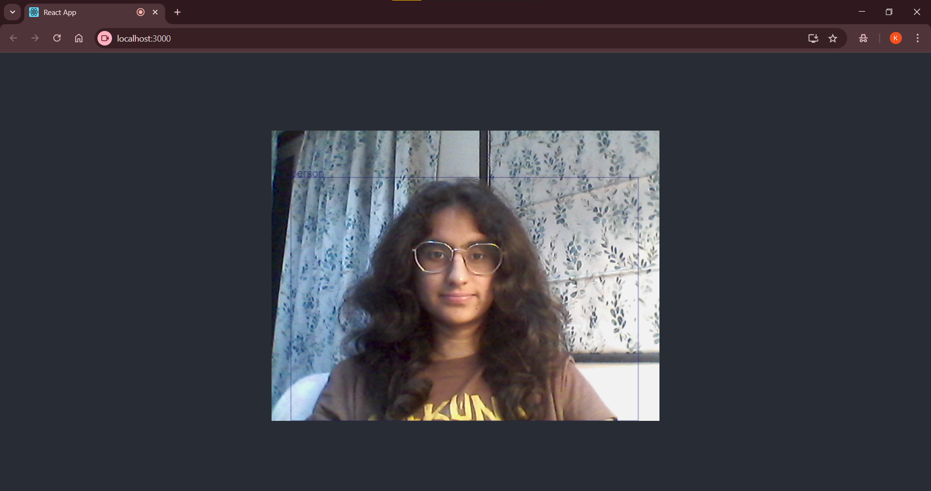
Result 2 : Object Detection App with TensorFlow.js and React.js using COCO-SSD UI

A real-time web application that uses TensorFlow.js and React.js to detect multiple objects in webcam feed or static images using the COCO-SSD pre-trained model. Fully runs in the browser with no backend.

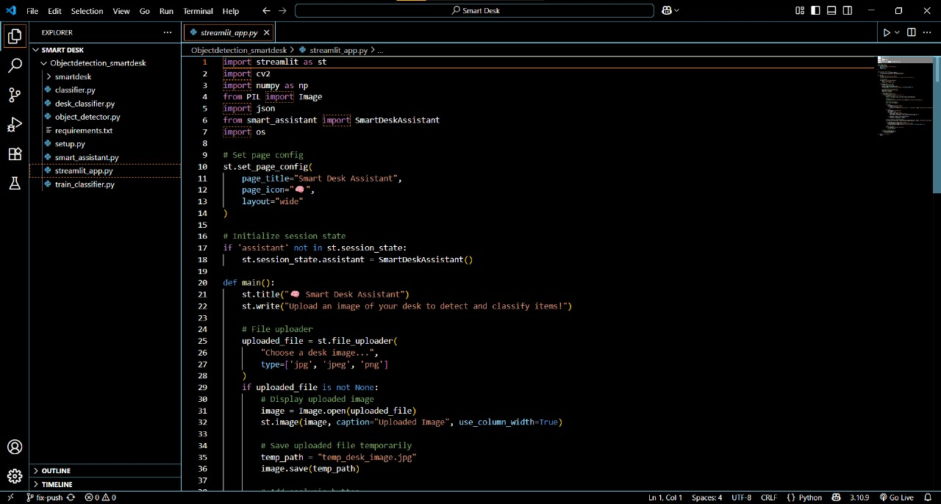
Code Snippet 3 : Smart Desk Final Project (Python)

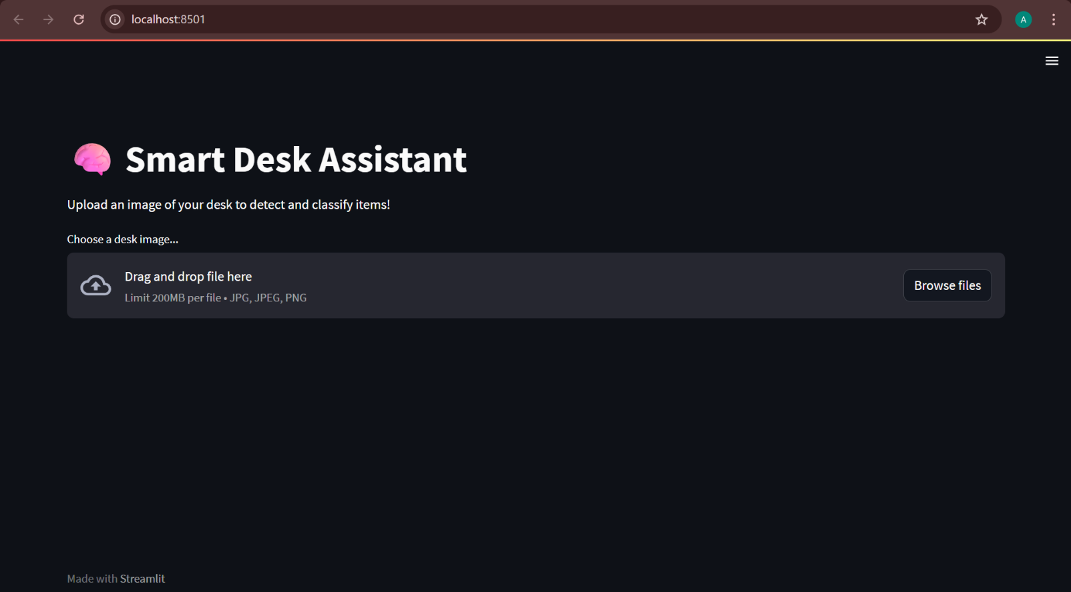
Result 3 : Smart Desk Final Project (Python) UI

This all-in-one Smart Desk Classifier project was developed during the Google Virtual Internship. It combines:
- Object Detection: Identifying desk items in real time
- Image Classification: Determining recyclability of uploaded images

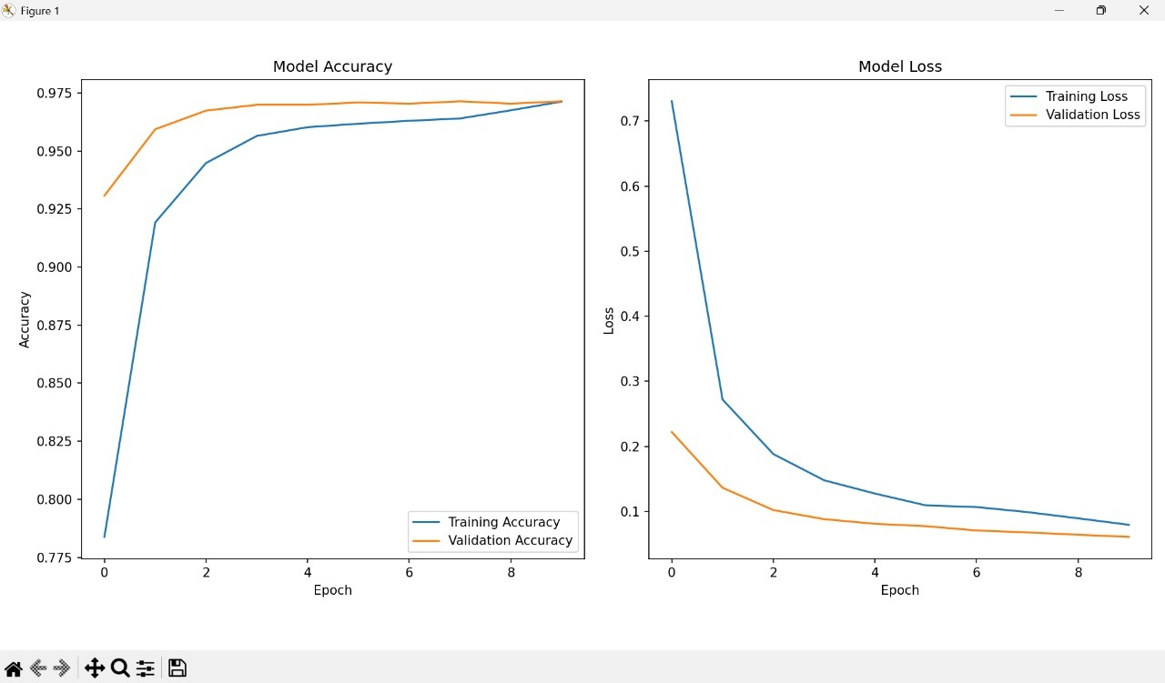
Graph 1 : Smart Desk Final Project (Python) Model Accuracy

Training and validation accuracy and loss curves over 10 epochs showing model convergence. The accuracy plot demonstrates steady improvement with training accuracy reaching approximately 97% and validation accuracy achieving around 96%, indicating good generalization without significant overfitting. The loss curves show consistent decrease in both training and validation loss, with final convergence around 0.1 and 0.05 respectively, confirming effective model learning and optimization.

7.4 FEEDBACK FROM INDUSTRY MENTOR INDUSTRY FEEDBACK SUMMARY

7.4 PHOTOS WITH GEOTAG AND REVIEWS

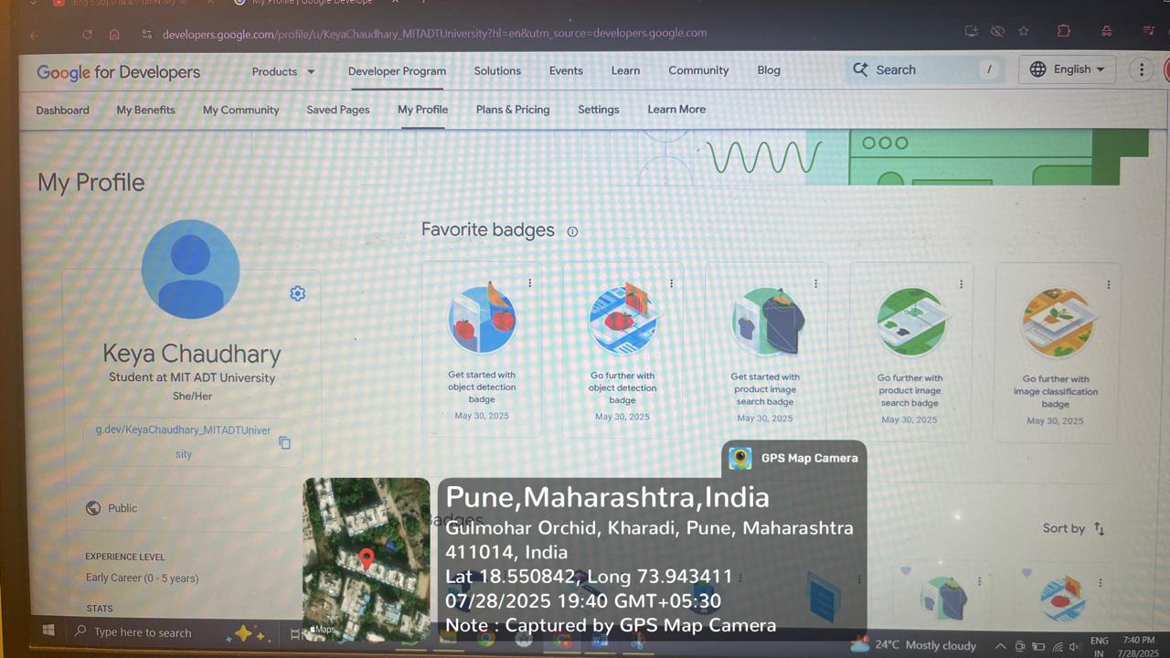

7.5 LOG BOOK
Date | Time Spent (Hrs) | Activities / Tasks Completed | Tools / Platforms Used
Week - 1
Day  1 | 2 | Program orientation, AI/ML internship structure overview, Google Developer Pathway Introduction | Google Developer Portal , Documentation
Day  2 | 3 | Python 3.8+ installation, virtual environment setup, Tensorflow 2.x installation, Google Colab Setup, Unit 1 :Tensorflow basics completion | Python, Tensorfow, pip,  Google Colab
Day  3 | 4 | Computer vision concepts study , OpenCV installation and setup, image loading and pre-processing basics | OpenCV, Numpy, Jupyter Notebook, Python
Day  4 | 4 | CNN architecture fundamentals , image manipulation with OpenCV , basic neural network understanding | TensorFlow, Numpy, OpenCV , Google Colab
Day  5 | 4 | Pre-trained models exploration, transfer learning concepts, image classification example practice | Tensorflow, Keras, Google Colab
Day  6 | 3 | Github repository creation, project structure setup, README documentation, version control basics | Git, Github, Markdown, VScode
Day 7 | 2 | Project planning documentation, three main projects outline | Github, Google Developer Portal , Documentation
Total Hours – 22

Week 2
Day 8 | 4 | Object Detection algorithms study, Unit 2 , 3, 4 : Object Detection | Google Developer Portal , Tensorflow Documentation
Day 9 | 4 | COCO-SSD model architecture study , 80 object classes exploration, Tensorflow.js environment setup | Tensorflow,js , COCO-SSD, Browser DevTools
Day 10 | 4 | Basic object detection implementation on static images, model integration testing | Tensorflow.js , HTML5, JavaScript, VScode
Day 11 | 4 | React.js development environment setup , webcam access components creation | React.js, Node.js , npm , VScode
Day 12 | 3 | Real-time object detection on video stream , bounding box overlays implementation | React.js , Tensorflow.js , Webcam API, HTML5
Day 13 | 2 | Performance Optimization , latency reduction , error handling implementation | React.js , Browser DevTools, JavaScript
Day 14 | 1 | Browser Compatibility testing, comprehensive documentation creation , demo video preparation | Multiple Browsers , Documentation tools, screen-recording
Total Hours – 22

Total Hours - 22
Week 3
Day  15 | 4 | Unit 5 & 6: Going Further with Image Classification completion,  deep learning concepts study | Google Developer Portal,  TensorFlow Documentation
Day  16 | 4 | Recyclable/non-recyclable image dataset collection and  preparation | Google Images, Data Collection  Tools, Python
Day  17 | 3 | Custom CNN architecture design, binary classification  model setup, data augmentation implementation | TensorFlow, Keras, NumPy,  Google Colab
Day  18 | 3 | CNN model training on recyclability dataset, validation  procedures implementation | TensorFlow, Keras, Google Colab,  Python
Day  19 | 3 | Hyperparameter tuning, model evaluation, confusion  matrices creation, performance graphs | TensorFlow, Matplotlib, Scikit  learn, Google Colab
Day  20 | 4 | Streamlit development environment setup, web interface  design for image upload | Streamlit, Python, pip, VS Code
Day  21 | 4 | Model integration for real-time inference, result  visualization, user feedback implementation | Streamlit, TensorFlow, Python,  Pillow
Total Hours - 29
Week 4
Day  22 | 5 | Object detection and image classification modules  combination, system architecture design | TensorFlow, TensorFlow.js, React.js,  Python
Day  23 | 4 | Smart Desk Classifier application creation, desk item  detection with recyclability analysis | Integrated Tech Stack, VS Code, Git
Day  24 | 2 | Comprehensive user interface design,  application testing | React.js, Streamlit, HTML5, CSS3
Day  25 | 1 | Comprehensive testing of all features, performance  optimization, bug fixes | Testing Frameworks, Browser  DevTools, Python
Day  26 | 6 | Technical documentation creation, demonstration videos  preparation, presentations setup | Documentation Tools, Screen  Recording, PowerPoint
Day  27 | 1 | Google Developer Profile creation with badges, final  presentation preparation | Google Developer Portal,  Presentation Tools
Day  28 | 2 | Portfolio submission, internship evaluation, reflection  summary completion, certificate application | Portfolio Platforms, Google Forms,  Documentation
Total Hours - 21

I hereby declare that the information recorded above is true and accurately reflects the work done by me during the internship.

Student Signature:
Date: / / 2025

Mentor Feedback:

Verified by Mentor:
Name: _________Keya Chaudhary________________, Signature:_________________________

